

Curriculum Council of WA

Manea Senior College

Physics TRIAL EXAMINATION
Written Paper Stage 2A
Question/Answer Booklet

Student Number: In figures

In words

Student name: ______________________________________ Teacher name: _________________

Time allowed for this paper
Reading time before commencing work: Ten minutes
Working time for paper: Three hours

Material required/recommended for this paper

To be provided by the supervisor
This Question/answer booklet; Formulae and constants sheet

To be provided by the candidate
Standard items: pens, pencils, eraser or correction fluid, ruler, highlighter

Special items: scientific non-programmable calculator

Important note to candidates
No other items may be taken into the examination room. It is your responsibility to ensure that you do not have any unauthorised notes or other items of a non-personal nature in the examination room. If you have any unauthorised material with you, hand it to the supervisor before reading any further.

All calculations are to be set out in detail. Marks may be awarded for correct equations and clear setting out, even if you cannot complete the calculation. Express numerical answers to two (2) or three (3) significant figures and include units where appropriate.
Student Marks
Section |  | Percentage of paper | Maximum mark | Student Mark
Section One  15 - 20 questions | Short Answer  35-45% | 42% | 45
Section Two  5 – 7 questions | Problem Solving  45-55% | 47% | 51
Section Three  1 -2 questions | Comprehension  5-15% | 11% | 12
Overall mark | Units and Significant figures |  | 2
Student total Mark
Student Percentage
Structure of this paper

Section of exam | Suggested working time | Number of questions | Number of questions to be attempted | Marks available
Section One | 70 minutes | 14 | all | 45
Section Two | 80 minutes | 6 | all | 51
Section Three | 30 minutes | 1 | all | 12
Overall |  |  |  | 2
 |  |  | [Total marks] | 111
Note: the ‘overall’ section represents marks allocated to appropriate use of units and significant digits in final answers to numerical problems.

Instructions to candidates

- The rules for the conduct of WACE examinations are detailed in the Student Information Handbook. Sitting this examination implies that you agree to abide by these rules.

- Answer all questions in the spaces provided in this Question/Answer Booklet.

- A blue or black ballpoint or ink pen should be used except for graphs were a pencil should be used.

This paper is a combination of material from
The Curriculum Council of Western Australia
and
Karen Harper; TDC Physics,
Department of Education and Training

All material is copyright.

Part of this paper is published by the Curriculum Council of Western Australia
27 Walters Drive
OSBORNE PARK WA 6017

SECTION ONE: SHORT ANSWER

This section has fourteen (14) questions. Attempt ALL questions. Answer in the spaces provided.

Allow approximately 50 minutes to complete this section [46 marks].

Question 1
Atom Q has an Atomic Number of 11 and has 12 neutrons. Atom R is a singly positively charged ion which also has an Atomic Number of 11 but has 11 neutrons. Use this information to fill in the table below: [3 marks]

atom | Number of electrons | Mass Number | Number of protons
Q | 11 | 23 | 11
R | 10 | 22 | 11

Question 2
Jemima measured the activity of a 10.00 g of radioisotope X. The original activity of the sample was 21.0 kBq and 12 days later the activity was 1.3125 kBq.
- What is the half-life of the radioisotope? [3 marks]
A₀ = 21 kBq 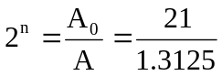
A = 1.3125 kBq
Total time = 12 days 2^{n} = 16

n = 4

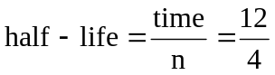
Half-life = 3.00 days

- Jemima also had a 100 g sample of X. Would this second sample have a greater, equal or smaller half-life than the original 10 g sample of X?

Circle the correct answer: GREATER EQUAL SMALLER
[1 mark]
Question 3
Phosphorus-32 decays to sulfur-32 by the emission of a beta particle:

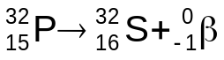

The masses of the particles involved are:

particle | Mass (μ)
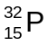 | 31.97272
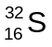 | 31.97091
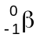 | 0.0005486

- Calculate the mass difference created by this decay in kilograms to two decimal places. [2 mark]

M_{d} = (31.97272) - (31.97091 + 0.0005486)
= 1.2614 x 10^{_3} μ

= 1.2614 x 10^{_3} x 1.6606 x 10⁻²⁷
m_{d} = 2.09 x 10⁻³⁰ kg

- This mass difference shows that energy is released during this reaction. Explain. [1 mark]

The mass on the RHS is less because the ‘missing’ mass has been converted to energy.

- Calculate the energy in joules released created by this decay. [2 marks]

E = mc²
= 2.09468 x 10⁻³⁰ x (3 x 10⁸)²
E = 1.89 x 10 x 10⁻¹³ J

Question 4
A nucleus of copper-65 (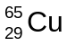) absorbs a neutron and shortly afterward emits a β particle. Write two balanced nuclear equations to show each of these processes.

Absorbing a neutron: 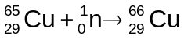 [1 mark]

Emitting a β particle: 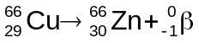 [1 mark]
Question 5
A beta particle has a mass of 9.11 x 10⁻³¹ kg and a speed of 2.50 x 10⁶ m s⁻¹. How fast would an alpha particle (mass 6.68 x 10⁻²⁷ kg) have to move in order to have the same momentum as the beta?
[2 marks]
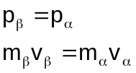 (1 mark)
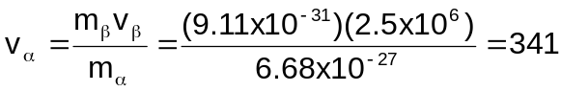 (1 mark)

Question 6
A 64.0 kg athlete stored elastic potential energy in her leg muscles when she was crouched, ready to jump vertically. When she jumped, she found that she could raise her centre of mass through a vertical distance of 1.34 m.

- Calculate how much gravitational potential energy she had at the highest point of the jump.
[2 marks]
Ep = mgh
Ep = (64 )(9.8 )(1.34 ) J
= 840 J

- Calculate the speed with which she left the ground as she took off. [2 marks]

Max E_{p} = max E_{k} = ½ m v²

840 J = ½ (64) v²
v = 5.12 ms⁻¹

Question 7
Identify “X” in each of the following equations and place its symbol in the brackets to the right of the equation. Only where appropriate, name the type of radiation produced, leave blank otherwise. [3 marks]

a. 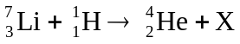 [ 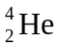 ] ___alpha particle __________

b. 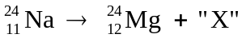 [ 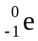 ] ____beta particle ____________
c. 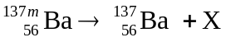 [ 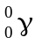 ] _____gamma radiation_____________
(note: m denotes in excited state)
Question 8
From rest, a sneeze can reach 161 kmh⁻¹ within 5.00 cm of your nose.

- Calculate the acceleration of the sneeze. [2 marks]

u = 0 v² = u² + 2as
v = 161 kmh⁻¹ (44.7222)² = 0 + 2 x a z 0.05
= 44.7222 ms⁻¹ 2000.08 = 0.1a
s = 0.0500 m a = 2.00 x 10⁴ ms⁻²

- Calculate how long it would take for the sneeze to reach 5.00 cm. [2 marks]
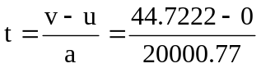
t = 2.24 x 10⁻³ s

Question 9
Rodney the Rodent applied a force of constant magnitude to push a 0.50 kg block of cheese across a smooth flat tabletop. The cheese accelerated from rest to a speed of 0.30 m s⁻¹ in a time of 20 seconds. Calculate the magnitude of the force that Rodney applied to the cheese. [2 marks]

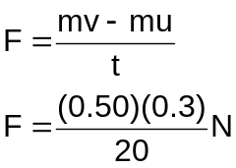

F = 7.5 x 10⁻³ N

Question 10
A car’s engine supplies 3.45 x 10⁶ J of energy every minute to run the car.

- What is the power output of the car?
[2 marks]

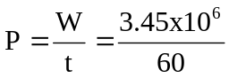

P = 57500 W

P = 5.75 x 10⁵ W

- Calculate the car’s maximum speed against a total resistance force of 1.50 x 10³ N.
[2 marks]

P = FV_{av}
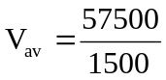
v = 38.3 ms⁻¹

Question 11
The graph shows how the force exerted by a cricket bat on a cricket ball varies with time.
Time (s)
Force
(N)
0.01
0.02
0.03
0.04
10
20
30
40
50
0

- The ball’s change in momentum can be determined from this graph. Is the change in momentum related to the gradient, or the area under the curve?
Circle the correct answer: GRADIENT AREA UNDER THE CURVE
[1 mark]

- Calculate the magnitude of the ball’s change in momentum between t = 0 and t = 0.02 s.
[2 marks]
Area under the curve = ½ (base) (height)
Change in momentum = ½ (0.02-0 s)(50-0 N) = 0.50 Ns
Question 12
A student is measuring the decay of a nuclear source. She finds that the source has a count of 15.60 kBq decays in a three hour period. Calculate the activity of the source. (2 marks)

A = ΔN = 15.60 x 10³ 1 mark
Δt (3 x 60 x 60)
A = 15.60 x 10³
10800
A = 1.44 Bq 1 mark

Question 13
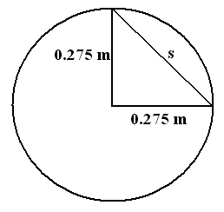
Heather is helping her Mum around the house by doing the weekly washing in the new washing machine. She reads in the instruction booklet that the spin cycle on a washing machine can spin as fast as 6.00 x 10² rpm (revolutions per minute). Using this information, Heather correctly calculates the speed and velocity of a sock on the edge of the tub after one and a quarter turns of the tub? Assume the tub has a diameter of 0.550 m. You must show all working for full marks. [3 marks]

600 rev = 60 s
1¼ rev = t
t = 0.125 s
(minus ½ mark if incorrect)t

SPEED VELOCITY
Circumference = π x diameter s = 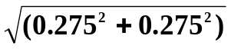
= π x 0.55 = 0.3889 m (1 mark)
= 1.7279 m t = 0.125 s
but 1¼ times around so
distance = 1.7279 x 1¼
= 2.1598 m ( ½ mark)

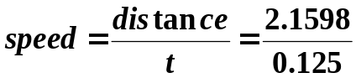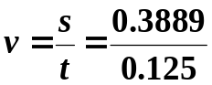

speed = 17.3 ms⁻¹ v = 3.11 ms⁻¹
( ½ mark) (1 mark)

Question 14
Chris and Rohan were playing golf and Chris was using one of the new jumbo sized metal “woods” to hit the golf ball. Find the change in momentum of the golf ball and the force delivered to the golf ball by the metal wood from the following data:

Speed of metal ‘wood’ at impact | = 70 m s⁻¹
Mass of the club head | = 150 g
Mass of golf ball | = 50 g
Speed of ball on leaving the club head | = 140 m s⁻¹
Time for which contact was made | = 0.02 s
[4 marks]
Change of momentum:
u = 0 ms⁻¹ Δρ = m (v – u)
v = 140 ms⁻¹ = 50 x 10⁻³ (140 – 0)
m = 50 x 10⁻³ kg Δρ = 7.0 kgms⁻¹ (2 marks)
Δρ = ?

Force on ball:
m _{(ball)} = 50 x 10⁻³ kg 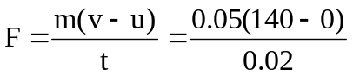
u = 0 ms⁻¹
v = 140 ms⁻¹ F = 350 N (2 marks)
t = 0.02 s
OR Ft = Δρ 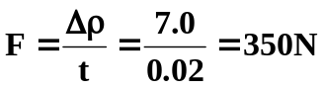

SECTION TWO: PROBLEM-SOLVING

This section has SIX (6) questions. Attempt ALL questions. Answer in the spaces provided.

Allow approximately 45 minutes to complete this section [51 marks].

Question 1 [11 marks]
One way to treat certain cancers is to irradiate them. Cobalt-60 is one radioisotope that can project a beam of gamma radiation to dose cancer patients.
- Two other kinds of radiation can be given off from radioisotopes, apart from gamma radiation. Name these two other radiations, and describe what each consists of. [4 marks]

Alpha: High speed helium nucleus, ejected from a radioactive nucleus
Beta: High speed electron, ejected from a radioactive nucleus

- Considering its use as a gamma source in cancer treatment, would you expect the half-life of the cobalt-60 to be long or short? Explain.
Circle the correct answer: LONG SHORT [1 mark]
Explanation:
Isotope should have the same (predictable) activity each time it is used over a period of time.
[1 mark]
- How does gamma treatment of cancer work? That is, what effect does a beam of gamma radiation have on cells? [2 marks]
Gamma rays are ionising, so they alter the chemical behaviour of compounds inside cells
This kills cells or stops them from reproducing

- The cobalt-60 gives off gamma radiation all the time, in all directions. This radiation must be stopped when it is not needed. Name a material suitable for blocking gamma emissions:

Lead (any dense material, eg uranium, is acceptable) [1 mark]

(e) Beta radiation can also be used in medical technology to diagnose certain conditions but alpha radiation is never used. Fully explain, using your understanding of alpha radiation, why alpha radiation is never used to diagnose medical conditions. [2 mark]

Alpha radiation can’t be detected outside the human body as can’t pass through skin.

Alpha is a high ionizing radiation so is dangerous to use inside the body.

Question 2 [7 marks]
Celia used a Geiger-Muller counter to measure the activity of a radioactive sample. The label said the sample activity was 47.8 kBq, but when Celia set up the G-M tube 50 cm from the source, she found the counter measured an average of 390 counts per second.
- Celia recorded count rates of 388, 372 and 410. Explain why all the counts were different.
[1 mark]
Radioactive decay is a series of random events

- Suggest two possible explanations for difference between the activity according to the label and Celia’s measurement.
[2 marks]

The quoted value is the total activity in the whole sample.
Celia can only measure the small fraction of particles that enter the G-M tube window.

- Celia moved the G-M tube further from the source. State how you would expect the reading to change as a result, and explain your reasoning.

Circle the correct answer: INCREASE STAY THE SAME DECREASE
[1 mark]
Explain your choice: [1 mark]

Radiation is attenuated by distance because the particles spread ever further apart
OR
Radiation is attenuated by distance because the particles ionise air molecules and lose energy

- Celia put away the radioactive source, but found the G-M tube was still measuring about 30 Bq, even with no radioactive material nearby. Explain what this radiation is and where it comes from.
[2 marks]

This is background radiation
a mix of radiation from natural sources such as rocks and cosmic rays, and from human sources such as nuclear reactors and atomic bomb fallout.
Question 3 [8 marks]
In 2001 a very rich American tried to fly a balloon non- stop around the world. It was launched at Northam and moved vertically upwards with a constant velocity of 4.00 m s⁻¹. Unfortunately after only 5.00 mins an essential piece of equipment became dislodged and fell out of a gap in the basket and fell towards the ground. (Assume no air resistance.)

(a) How high was the balloon after 5.0 mins? (2 marks)
V = 4.0 ms⁻¹ as a constant velocity, can use 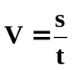
t = 5 x 60 = 300 s s = V x t
= 4.0 x 300 (1 mark)
s = 1 200 m

s = 1.2 x 10³ m (1 mark)

(b) With what speed will it impact on the ground? [3 marks]

Let up be negative and down be positive
s = 1200 m v² = u² + 2gs
u = -4.0 ms⁻¹ v² = (-4.00)² + (2 x 9.8 x 1200)
v = ? = 16 + 23520
g = 9.8 ms⁻² = 23536
v = 153 ms⁻¹
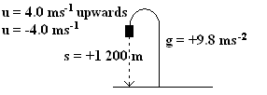

(c) Neglecting air resistance, how long does it take for the essential piece of equipment to reach the
ground? [3 marks]

u = -4.0 ms⁻¹ 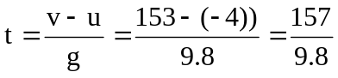
g = +9.8 ms⁻²
t = 16.0 s

Question 4 [8 marks]
The mass of a rocket resting on the launch pad is 3.00 x 10³ kg.

- Calculate the weight of the rocket, in newtons, while it is sitting on the launch pad with its engine turned off. [2 marks]

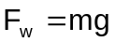

- Calculate the magnitude of the resultant force required to accelerate the rocket upwards from the launch pad at 40.0 m s⁻². [2 marks]

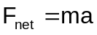

- Using your answers to (a) and (b) above, calculate the thrust force provided by the rocket motor at the moment of lift-off. [2 marks]

Total thrust = force required to lift rocket + force required to accelerate rocket
Thrust = (1.20 x 10⁵ N) + (2.94 x 10⁴ N) = 1.49 x 10⁵ N
Question 4 continues
- Clearly show, using arrows to represent force vectors, the magnitude and directions of all the forces acting on the rocket at the moment it lifts off the launch pad with an acceleration of 40.0 m s⁻² upwards: [2 marks]

Thrust 1.49 x 10⁵ N  Weight 2.94 x 10⁴ N | 1 each

Question 5 [8 marks]
Sam and Max used a motion detector to measure the speed of a motor scooter. Their results made a straight line graph when they plotted kinetic energy on one axis and the square of the scooter’s speed on the other axis:
v² (m² s⁻²)
kinetic energy (J)
100
200
300
400
1 x 10⁴
2 x 10⁴
3 x 10⁴

- Calculate the gradient 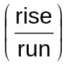 of this graph. [3 marks]

Rise=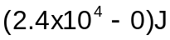
Run=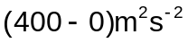
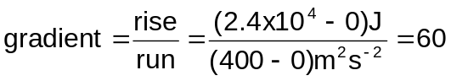kg

- Show that the gradient of this graph represents ( ½ x scooter’s mass). [3 marks]

E_{k} = ½ m v²
Gradient = 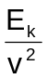
=½ m

- Use the gradient to calculate the mass of the scooter. If you could not obtain an answer to part (a), use gradient = 65 kg. [2 mark]
=½ m
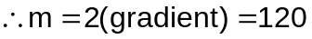kg

OR if no gradient and used 65,

=½ m
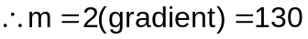kg
Question 6 [9 marks]

At the Royal Show a gunman was demonstrating an unusual stunt. He used a 70.0 cm long rifle which was placed on the ground so that its barrel points upwards. A 300 g rubber ball was dropped downwards towards the rifle barrel by an assistant. The gunman fires the gun so that the ball, which is travelling at 4.00 ms⁻¹ downwards, is hit when it is 10 cm from the top of the barrel. The 20.0 g bullet was travelling at 460 ms⁻¹ upwards when it hits the ball and remains in the ball causing the ball to change direction and travel upwards. The assistant measured the maximum height above the ground that the ball reached after it had been hit by the bullet. What measurement did the assistant get? (Assume no loss of energy to other forms and no friction.)

  - Using your understanding of conservation of momentum, calculate the initial velocity with which the ball / bullet combination moves upwards. Don’t forget direction. (4 marks)

Let up be negative and down be positive.
m₁ _{bullet} = 0.02 kg
u₁ _{bullet} = -460 ms⁻¹
v₁ _{bullet} = ? but same as ball so v₁ = v₂ so now just v

m₂ _{ball} = 0.3 kg
u₂ _{ball} = +4.00 ms⁻¹
v_{2 ball} = ? but same as bullet so v₁ = v₂ so now just v

m₁u₁ + m₂u₂ = m₁v₁ + m₂v₂
or m₁u₁ + m₂u₂ = v ( m₁ + m₂)

(0.02 x -460) + (0.3 x +4) = v (0.02 + 0.3)
-9.2 + 1.2 = 0.32v
-8.0 = 0.32v
v = -8.0 ÷ 0.32
v = -25 ms⁻¹ or 25 ms⁻¹ upwards. (4 marks)

  - Knowing the initial velocity of the ball / bullet combination, find the distance upwards the ball will travel after being hit by the bullet. (3 marks)

Now ball/bullet will experience gravity slowing it down until it stops

v² = u² + 2gs
- = (-25)² + (2 x 9.8 x s)
0 = 625 + 19.6s
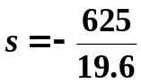
s = -31.8877 m or 31.8877 m upwards (3 marks)

  - Now find the maximum height the ball will reach above the ground. (2 marks)

but rifle is 0.7 m tall and ball was 0.1 m above rifle when hit so total height reached was
s = 31.8877 + 0.7 + 0.1
s = 32.6877 m upwards
height above ground reached = 32.7 m ( 2 mark)

SECTION THREE: COMPREHENSION

This section has ONE (1) question. Attempt ALL sections. Answer in the spaces provided.

Allow approximately 25 minutes to complete this section [12 marks].

A group of testers at a car design centre drove a number of cars directly into a solid barrier and measured the ‘collapse length’ CL. The testers used the same type of car in each test. They defined the collapse length as the difference between the overall length of the car before collision (ℓ_{i}), and the length after collision (ℓ_{f}).

Mathematically, this can be shown as: CL = ℓ_{i} - ℓ_{f}

The diagram shows how the testers measured ℓ_{i} and ℓ_{f}.
Before collision
After collision

ℓ_{i}
ℓ_{f}

The following table shows their results.

Impact  speed, v  [m s^{–1}] | Collapse  length, CL  [m] | 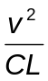  [m s⁻²]
6.0 | 0.22 | 164
10.0 | 0.35 | 286
14.0 | 0.50 | 392
19.0 | 0.74 | 488
22.0 | 0.93 | 520

The test group found that the force F acting on a car of mass m during a collision at an impact speed of u is given by
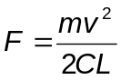.

- Use the table of values to plot a graph of (y-axis) vs v (x-axis) on the graph paper. Draw a smooth line of best fit, by eye. [3 marks]

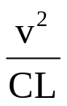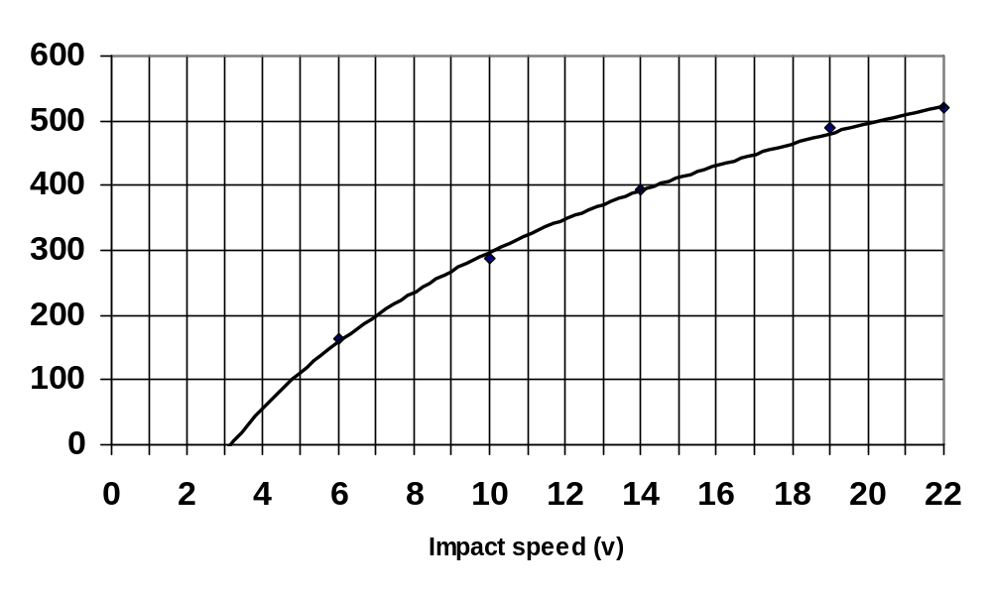

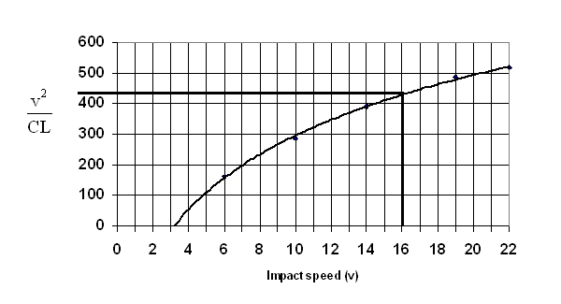
- Use the graph to determine the value of for a car impacting the barrier at 16 m s⁻¹. [1 marks]

From the graph the value
Is about 440 ms⁻²

Estimates may vary between
420 and 470. Units are essential
for full marks.

- Calculate the force acting on a 1500 kg car impacting the barrier at a speed of 16 m s⁻¹. If you could not obtain an answer to part (c), use = 550 m s⁻². [2 marks]

=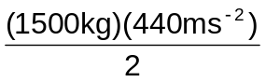
F = 3.3 x 10⁵ N
OR
= 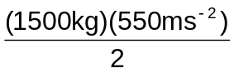
F = 4.1 x 10⁵ N

- If the car in the previous questions was 3.20 m in length, what would be the resultant length after the crash? [1 mark]
and from part (c), F = 4.1 x 10⁵ N and = 440 ms⁻²
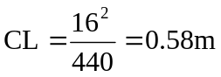
Resultant length = 3.20 – 0.58 = 2.62 m

- One of the testers called the force acting on the car during the collision an ‘average force’. Explain why this force is an average force. [2 marks]
The actual force acting on the car varies over the impact time: it increases, then decreases
The force as calculated above is the single value that would have the same overall effect as the actual, varying force.

- Cars today are designed so that the bonnet does crumple. Explain, using your understanding of physics principles, why it is safer on the passengers in the car if the bonnet crumples. [3 marks]
  - This is due to Newton’s second law
  - Change in momentum, Δρ = m (v-u) also Ft = Δρ
  - Change in momentum in car crash can’t be altered however if change in momentum occurs over a longer time, then force on passengers is decreased.
  - By the bonnet crumpling, the time does increase and force less on passengers.

END OF 2A PAPER

Part of this paper is published by the Curriculum Council of Western Australia
27 Walters Drive
OSBORNE PARK WA 6017

